# Cluster Topology

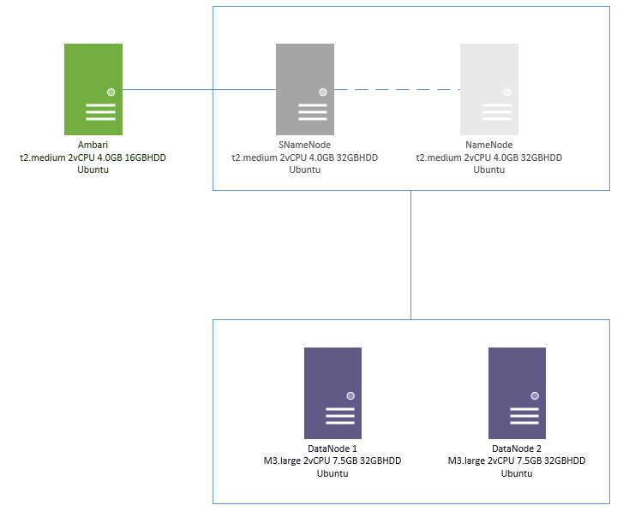

# EC2 Instance Launch

1. Open the Amazon EC2 console at <https://console.aws.amazon.com/ec2/> .
2. Choose Launch Instance.
3. Choose an Amazon Machine Image (AMI)  - (Ubuntu)
4. Choose an Instance
5. Configure instance set the instance region etc.
6. Add more storage if needed
7. Add a tag to the instance
8. Set the security group during setup set - Ports needed for communication – 8080 for Ambari is required initially
9. Review and launch
10. Create a new key-pair or use existing.
11. Instance launch complete

# Logging into EC2 from Putty

1. Download putty & puttygen from <http://www.putty.org/>
2. Note:

.pem file is what we have download from AWS when we created our key-pair. This is only a one time download and we cannot download it again. our software is asking for .pem file. Now we are the one who needs to locate that file. we might have downloaded it on our laptop/desktop...etc.

For Putty (windows ssh client), it does not support .pem format. Hence we have to convert it to .ppk format using PuTTyGen. It’s essentially .pem but in a different format so that Putty can work with it.

1. Generate the .ppk file for .pem for putty to use

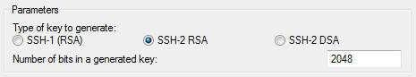

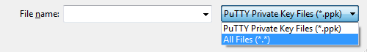

1. Get the DNS name from amazon ec2 console
2. Login to AWS EC2 instance from putty using the DNS name and 22 security port set the auth to ppk file

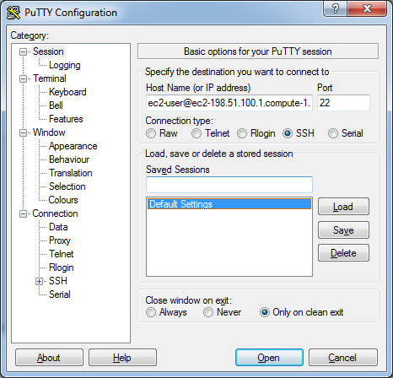

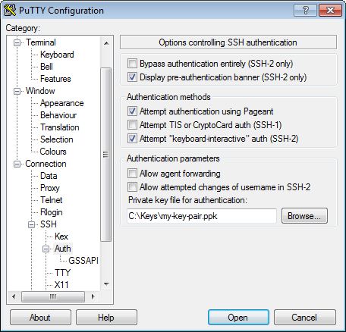

1. Login successful

# EC2 Instance Configuration

1. Add new user

root>sudo adduser developer

1. switch to new user account

root>sudo su – developer

1. create .ssh folder

developer>mkdir .ssh

1. Create new file authorized_keys

developer>touch .ssh/authorized_keys

1. Change setting to writ into file

developer>chmod 777 .ssh/authorized_keys

developer>chmod 777 .ssh

1. Copy privatekey to new user

developer>logout

root>cat .ssh/authorized_keys > /home/developer/.ssh/authorized_keys

1. Switch back to developer and change permissions

root>sudo su – developer

developer>chmod 700 .ssh/authorized_keys

developer>chmod 700 .ssh

1. Assign root privileges to developer

developer>logout

root>sudo visudo

developer ALL=(ALL:ALL) NOPASSWD: ALL

1. Install wget, curl, Oracle java

developer>sudo su - developer

developer>sudo apt-get update

developer>sudo apt-get install wget

developer>sudo apt-get install curl

developer>sudo apt-get install default-jre

developer>sudo apt-get install default-jdk

developer>sudo apt-get install python-software-properties

developer>sudo add-apt-repository ppa:webupd8team/java

developer>sudo apt-get update

developer>sudo apt-get install oracle-java8-installer

developer>sudo update-alternatives --config java

developer>sudo update-alternatives --config javac

developer>sudo nano /etc/environment

JAVA_HOME="/usr/lib/jvm/java-7-oracle”

1. Install ntp

developer> sudo apt-get install ntpd

developer> sudo service ntp start

# EC2 create Image

Create AMI image from already configured instance to launch multiple instances at once.

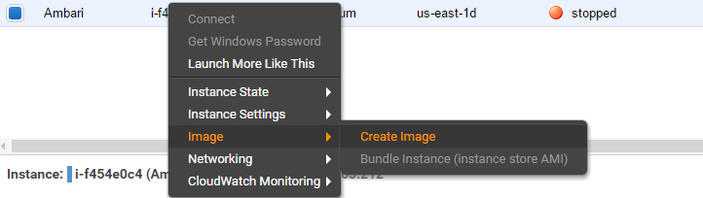

# Ambari Installation

1. Login as developer in one of the machines
2. Download repositories and update apt-get

wget -nv http://public-repo-1.hortonworks.com/ambari/ubuntu14/2.x/updates/2.1.2/ambari.list -O /etc/apt/sources.list.d/ambari.list

apt-key adv --recv-keys --keyserver keyserver.ubuntu.com B9733A7A07513CAD

apt-get update

1. Check successful installation

apt-cache showpkg ambari-server

apt-cache showpkg ambari-agent

apt-cache showpkg ambari-metrics-assembly

*We should see Ambari notes

1. Install the Ambari bits. This also installs the default PostgreSQL Ambari database.

apt-get install ambari-server

1. After installation is complete setup ambari using

sudo ambari-server setup

1. By default, Ambari Server runs under root. Accept the default (n) at the Customize user account for ambari-server daemon prompt, to proceed as root. Otherwise select (y) and customize the user account
2. Select the default database and default user/password/schema or customize it.
3. Once the setup is complete start ambari using

sudo ambary-server start

# HDP Installation

1. Login to ambary console

<https://hostname:8080>

1. Use default username and password as admin/admin
2. Launch a cluster
3. Set the name of cluster, select the stack and select the repo we want to install in this case its Ubuntu 14
4. In install options set the target hosts and provide the .pem key and confirm hosts
5. Once host registration is complete choose all the services we want to install (choose only the ones we want)
6. Set the namenode, secondarynamenode, resourcemanager, regionserver, nodemanager and all other servers (hive, spark, zookeeper, metrics etc.)
7. Review the option and install the services on those machines
8. Once all services all installed, services are started and your cluster is ready for use.